Search Ohio Reserves – Unclaimed Holds List

Requested items are held for pick-up for 10 days. SearchOhio and OhioLINK unclaimed holds should be pulled each time the unclaimed holds report is processed. Staff should not manually extend holds.

- From the Polaris toolbar select Utilities, then Reports and Notices.
- Select Reports and Notices.
1

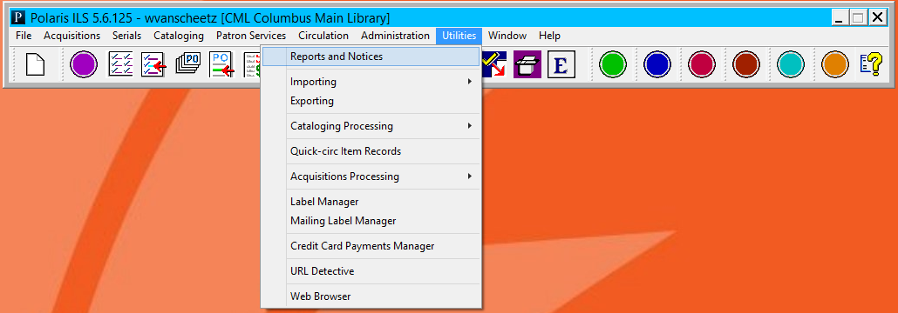
2

- From the categories on the left select Circulation, then ILL.
- From the available reports select Unclaimed ILL Items.

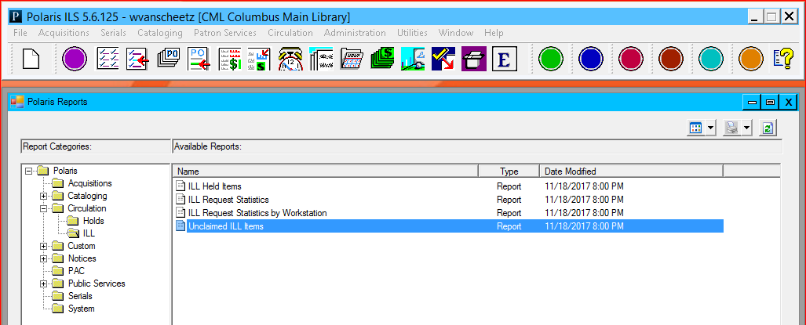
4
3

- Select your location and click Submit.

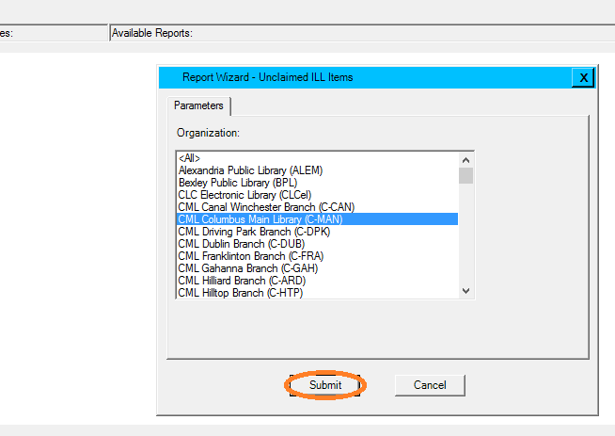
5
- Find item on customer holds shelf.
- Open the bulk check in screen in Polaris.
7
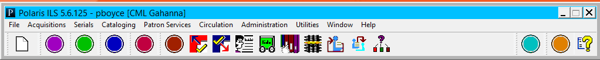

- Scan the item barcode into the check-in screen.
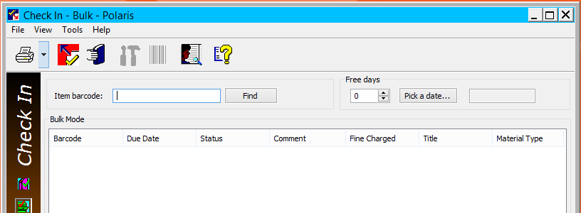
8

- Click Yes on the Item Blocks window.
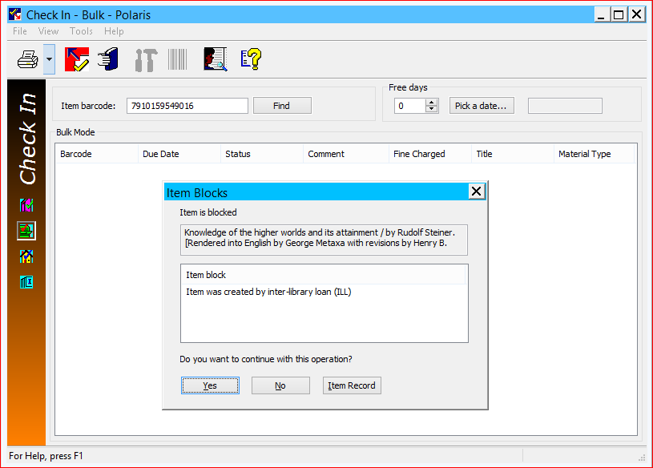
9

- Click No in the Polaris – Hold ILL window.
No receipt will print. (This message will appear even though the item has gone to Unclaimed.)
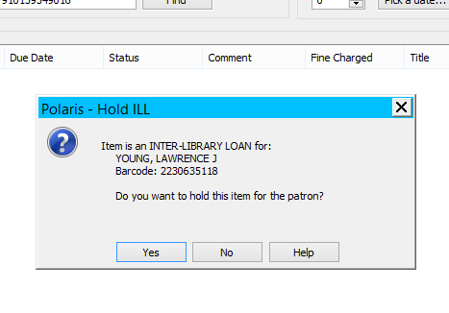
10

- Write R on the SearchOhio/OhioLINK sticker with a red marker.
- Cross out 800 at the top
- Circle the 3-digit number of the lending library.
12

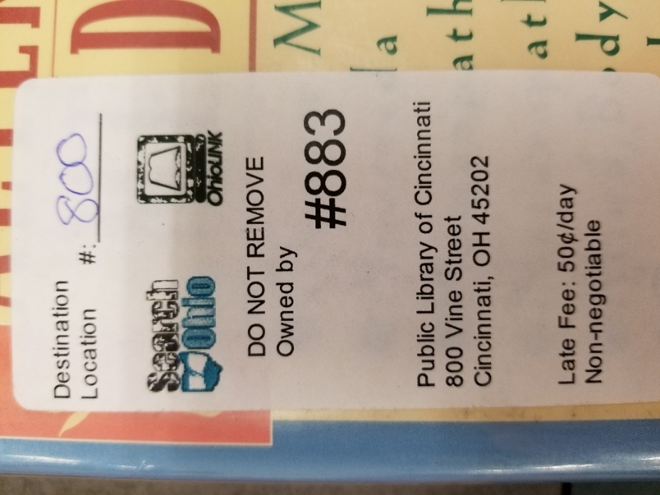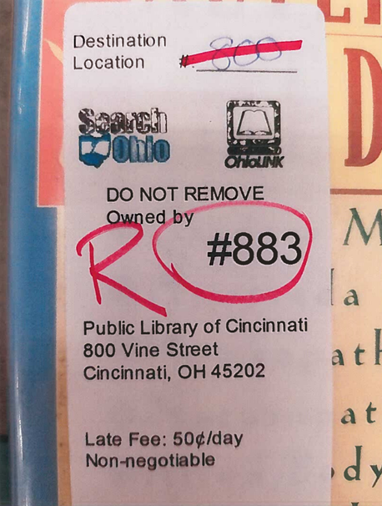
11
13
- Place the item in an outgoing OPS-H delivery box.

