Checking in a Returned SearchOhio or OhioLINK Item

- Open the Bulk Check In screen in Polaris (F2).
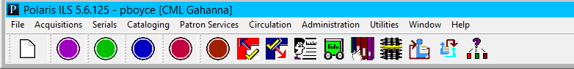
1

- Scan the owning library’s item barcode.
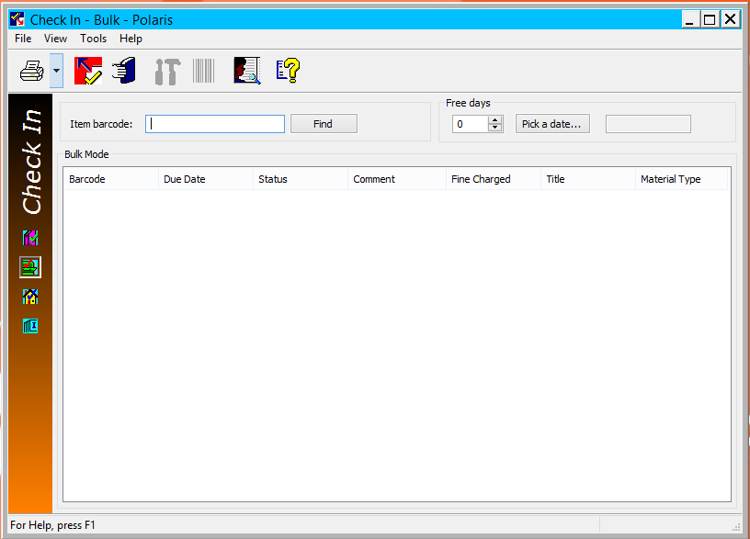
2

- Click Yes in the Item Blocks window.
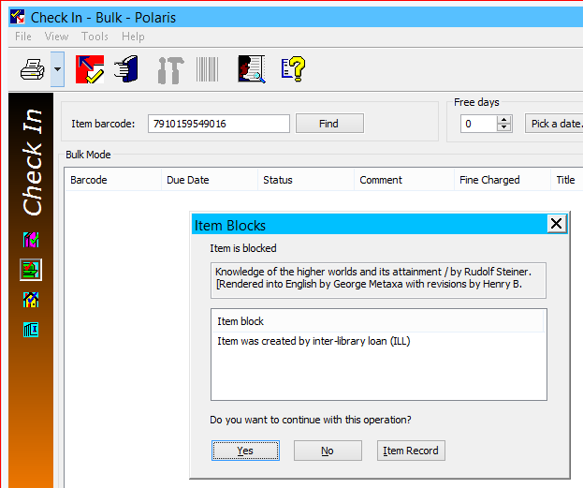
A slip will not print. The item will show Out In.
3

- Write R on the SearchOhio/OhioLINK sticker with a red marker.
- Cross out 800 at the top.
- Circle the 3-digit number of the lending library.
5
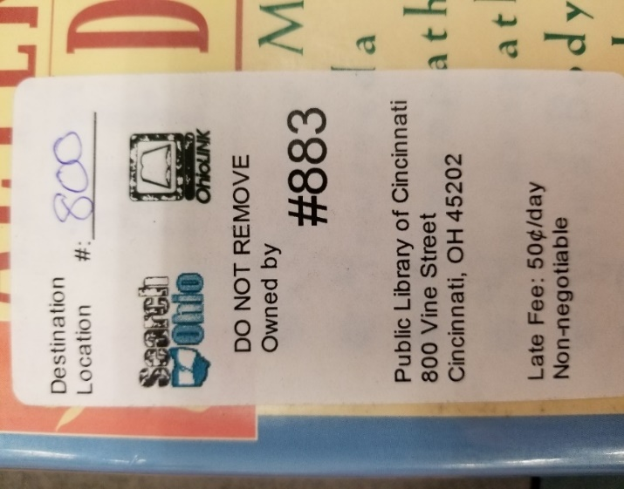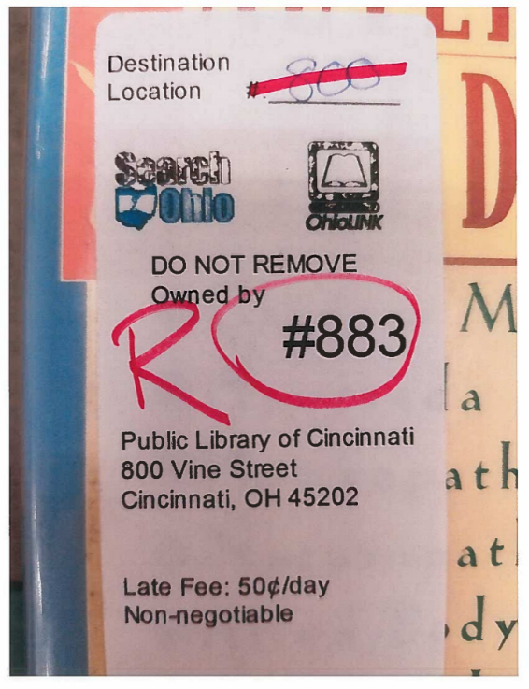
4
6
- Place the item in an outgoing OPS-H delivery box.

- If a returned item is damaged, refer to the “Charging for a Damaged SearchOhio or OhioLINK Item” workflow.

- If a returned item is missing pieces, refer to the “Incomplete Items” Service Expectation.
These items will continue to accumulate overdue fines until the item is charged to the customer’s account or the item is checked in.

- Refer to the Fine and Fee Negotiations Service Expectation for further information.

