Processing SearchOhio/OhioLINK Requests-to-Fill

Requests from SearchOhio and OhioLINK should be pulled each time the standard RTF report is processed.

Printing the SearchOhio/OhioLINK Requests-to-Fill

- Select Circulation - Request Manager
- Click INN icon on left side of workform
- Select Print – List View
- Pull items with the exact barcode when possible.
(See page 4 for instructions on filling the request with a different barcode.)
- Make any not-found items Missing.
(Changing the item status to Missing pushes the request on to the next possible lending library.)

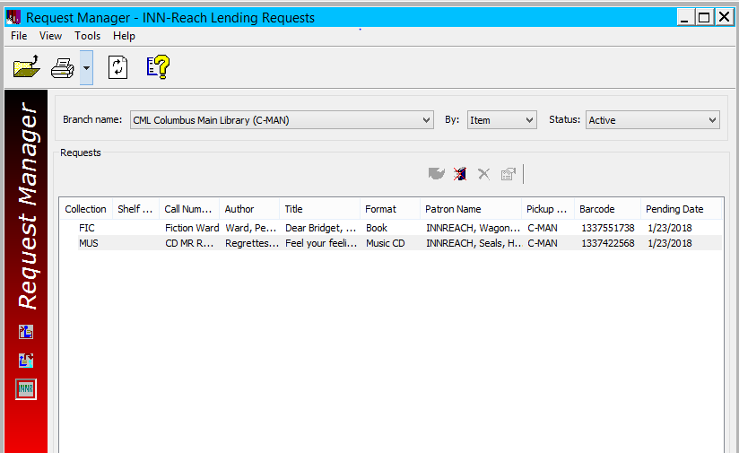
3
2

Checking in SearchOhio/OhioLINK Requests-to-Fill
After pulling items from your location’s SearchOhio RTF, the items will need special processing before going in your outgoing delivery. Every item should be accompanied by a slip containing the Requesting Library’s location number and other information about the request.

- Select Check In - Bulk
- Scan item barcode.
- Select Yes in the dialogue box to transfer item for hold.
- The item will show as “Held.” This is normal for SearchOhio/OhioLINK items.
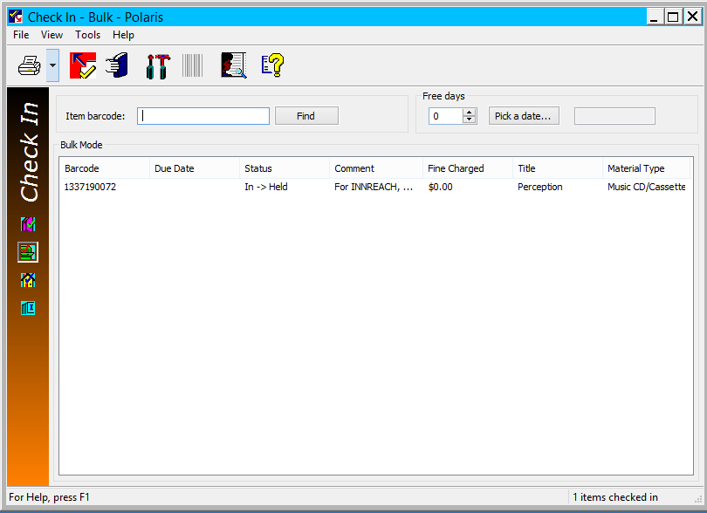
- A slip will print.
2
1
4

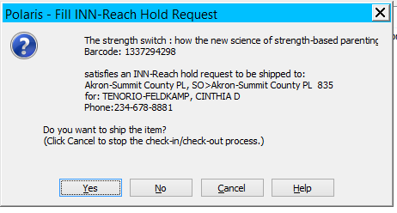

3

- Place a SearchOhio sticker on the back of the item with the top left corner folded down for easy removal.
- Identify the requesting location’s transportation number from the slip. Write the requesting library’s number on the line at the top of the SearchOhio sticker.
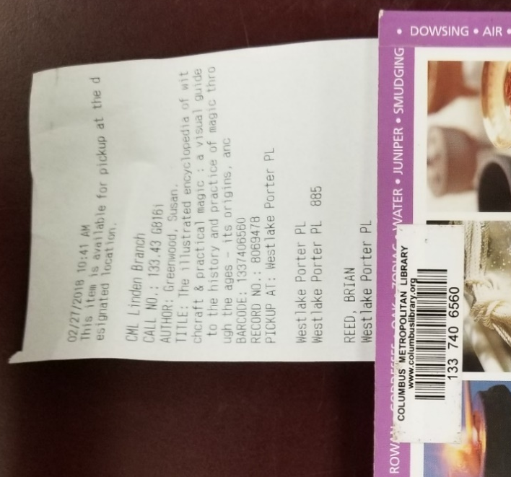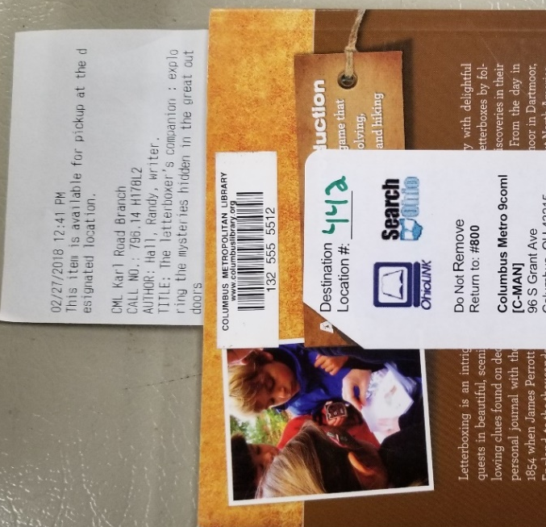
7
8
6
- Place the item in the OPS H box (or OPS SO box), being sure that the slip is still in the item.

SearchOhio/OhioLINK requests can be filled with an item from the same bibliographic record but with a different barcode.

- To do this use the Fill Request Now button on the Hold Request screen.
- Scan the item barcode.
1
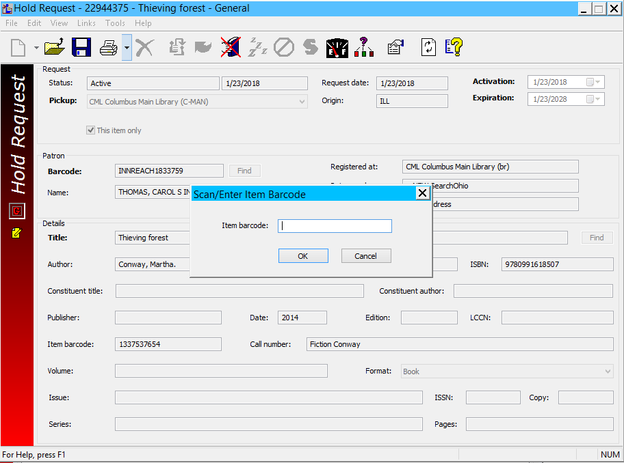
2

Troubleshooting
An item is checked in and a slip prints horizontally instead of vertically. Below, the slip on the right is the correct slip.
- A “sideways” slip is generated when an outgoing hold is checked in once at a CML location and then again at a different CML location.
- This action causes an in-transit loop, preventing the hold from reaching the pick-up destination.
1
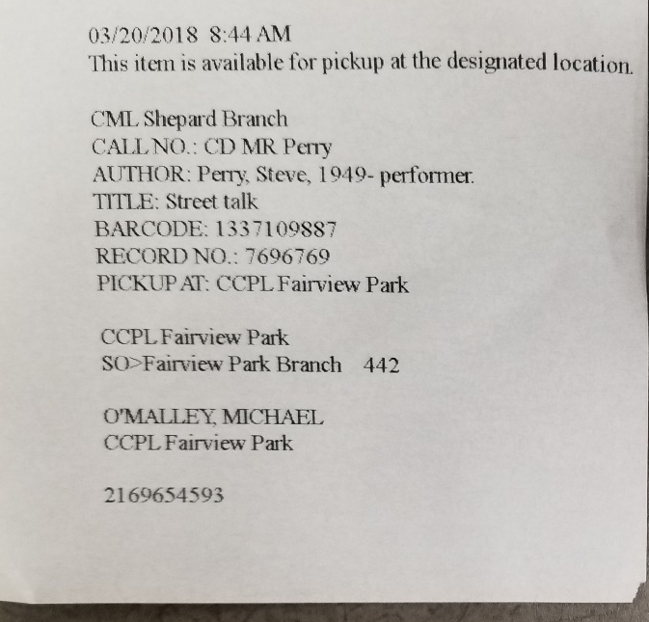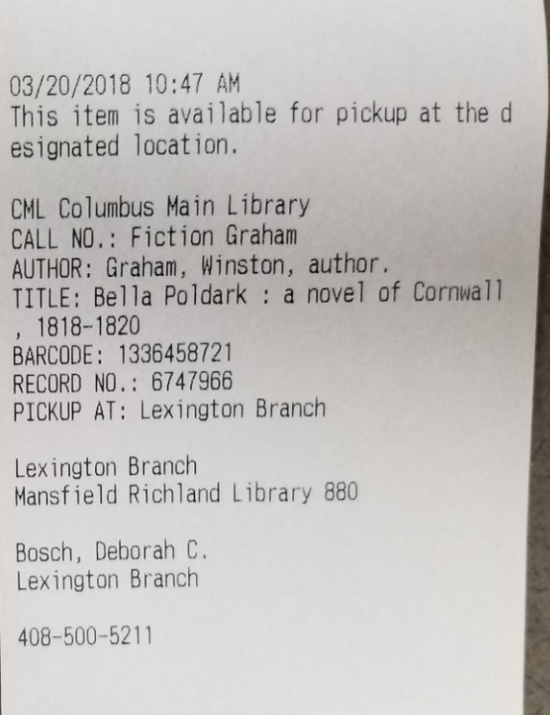
- To correct this error, call the branch from where the request was originally filled. This information is indicated on the top portion of the slip.
- Ask the branch to check the item in.
- When the item is checked in at the original location the user will be asked by a Polaris prompt if he or she wants to ship the item. Click Yes. The correct style slip (above right) will print out. This slip should be thrown away.
- The incorrect, horizontally printed slip can still be used to send the item to the SearchOhio/OhioLINK library. The destination in Polaris is now correct for the hold.

