Receiving SearchOhio/OhioLINK incoming holds for customers
Like ILL items, SearchOhio and OhioLINK items will arrive with special stickers that should not be removed:
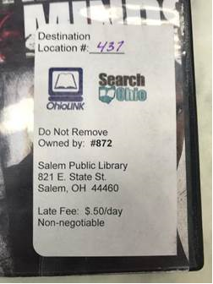 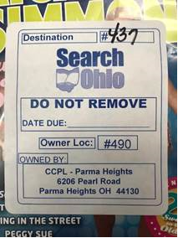
Due to Polaris permissions, SearchOhio and OhioLINK reserves can be received by CSS and above.
- Open Circulation
- Select ILL Requests
- Change Search Mode from Normal to SQL
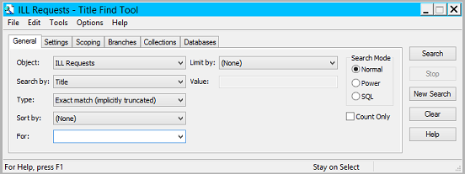
3

- Select Find Requests by owning library barcode
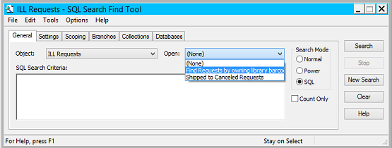
4

- Replace ENTERBARCODEHERE by scanning or typing the owning library’s item barcode
- Click Search

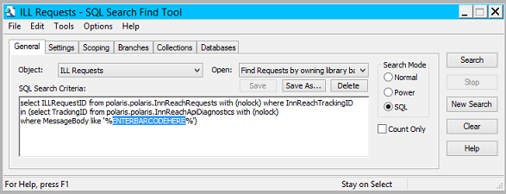
6
5

- Right click on the item and select Receive

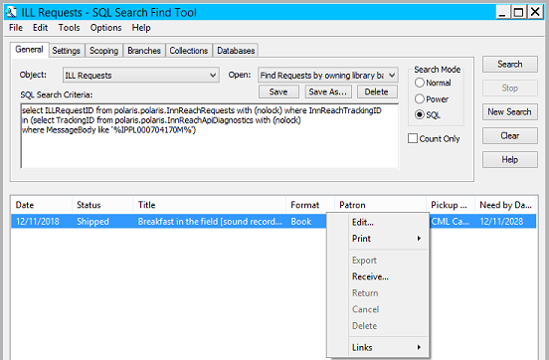
7

- Scan or type the owning library’s item barcode
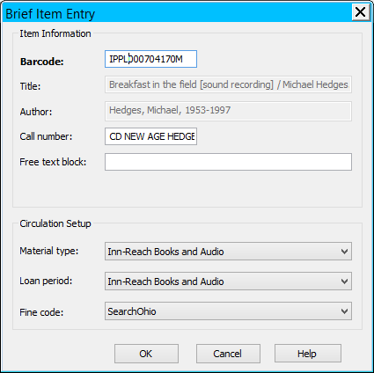
- Click OK
A hold receipt will print.
Remove any slips that come with the item and discard.
8
- Put the item on self-pickup hold shelves.
  - Requested items are held for pick-up for 10 days. Held items cannot be extended in Polaris; do not manually extend holds longer than 10 days.
  - Customers may use self-checkouts for these materials.
  - Polaris and Self-Check software will allow the checkout of the SearchOhio item on any library card.

NOTE: Due to variations in item barcodes used by libraries, some items may not be able to be checked out at the self-checkout stations. If you encounter something like this, please document the item barcode so that IT can make adjustments.
9

Troubleshooting
- An incoming item cannot be received because it creates a duplicate record.
  - Create a temporary barcode by placing a “B” in front of the SearchOhio/OhioLINK item’s barcode when receiving the item from the “shipped” status.
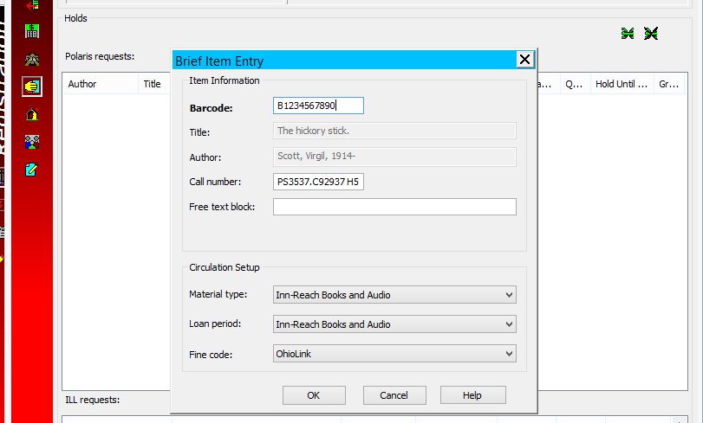
  - Note the SearchOhio/OhioLINK sticker on the item by writing “B[Item number].”
  - Cover up the item’s barcode with a removable sticker, so the duplicate item doesn’t accidentally get checked out or checked in when returned.
  - Shelve item with ILL holds.
  - When the item is checked out and checked in, staff will need to type the “B” before the number and the item will become a “returned ILL” per usual.

- An incoming item is accidentally checked in before it can be checked out to the customer.
  - Place a new hold for the customer.
  - Return item per standard methods. Customer will need to wait for next available item.

- An incoming item comes in but doesn’t have a request in Polaris
  - Return item per standard methods.

