How to Place a SearchOhio/OhioLINK Hold

- The limit for SearchOhio/OhioLINK requests is 75 per customer. This includes requested, checked-out, or in-transit items.
- Requests cannot be suspended. Requested items will be held for pick-up for 10 days.
- In SearchOhio, customers will only be able to successfully request items that are checked in and do not have existing holds on them. In OhioLINK, customers will be able to place holds on items.

Order for Placing Requests

When requesting materials, customers should be offered the following options in this order:
- CLC catalog
- SearchOhio
- OhioLINK
- ILL
- Request to Purchase

Verifying Holdings when Placing a SearchOhio/OhioLink Request

- Open the CLC catalog, www.columbuslibrary.org
- Enter the search terms in the Search by box.

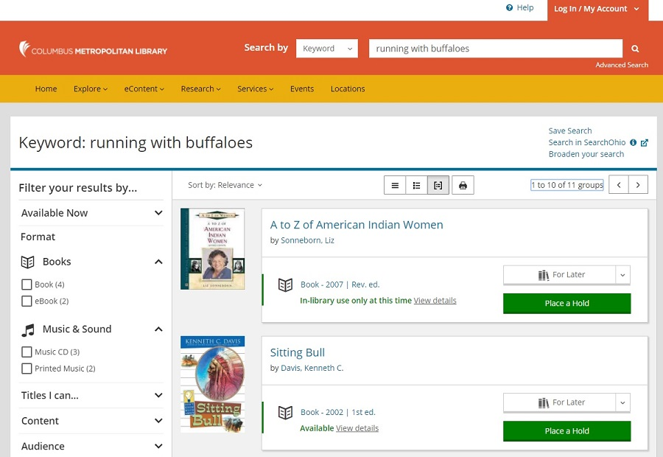
2

- Once you have verified the item is not available in the CLC catalog,
click on Search in SearchOhio on the top right side.

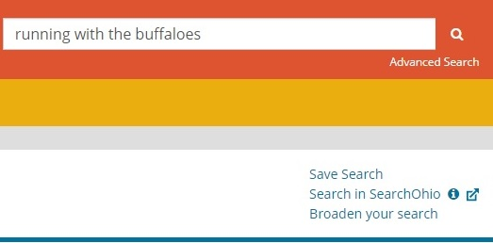

3

- The SearchOhio catalog will open. The search field will auto populate with the search terms.
- Locate the correct item from the catalog and click “Request It.”

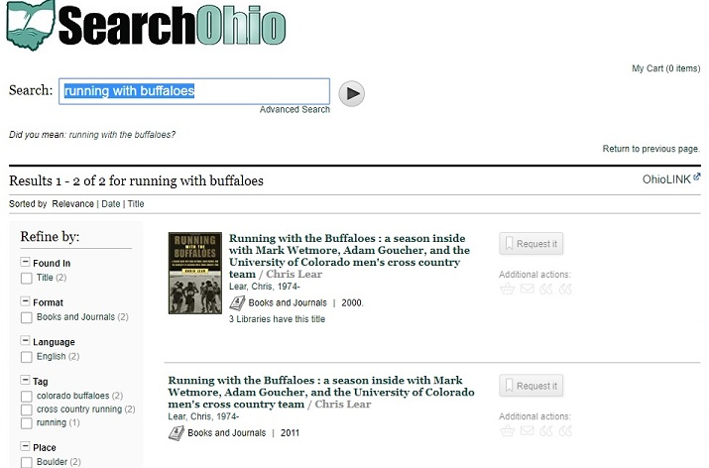
5
4

An error message will appear if the item is unable to be placed on hold.

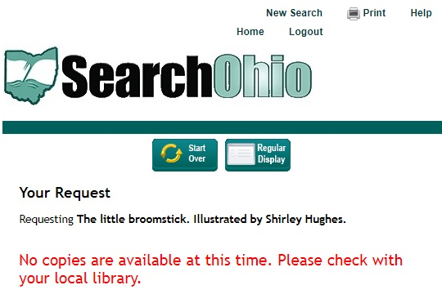

Possible reasons for the error:
  - All items of this title are currently checked out
  - The location does not circulate the requested item

Inform the customer that the item is not currently available through SearchOhio. Then move on to OhioLINK – see further instructions on page 5.

- For the field With which library are you affiliated? select Columbus Metropolitan Library.
Click Submit.
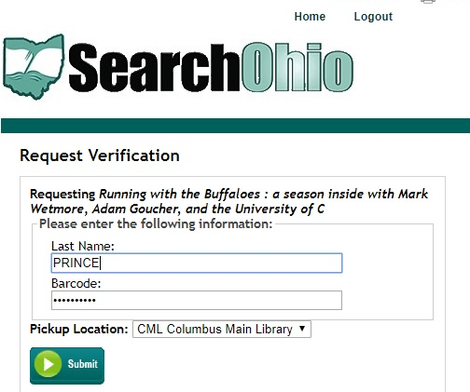
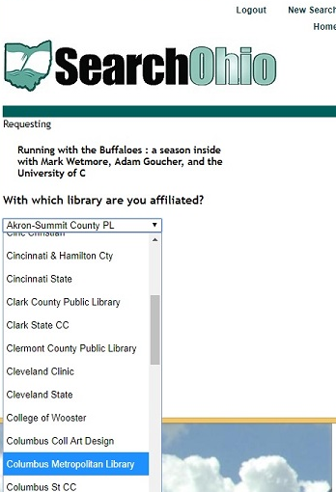
6

- On the Request Verification screen:
  - Enter the customer’s Last Name and Library Card Number
7a
  - Select the customer’s Pickup Location
  - Click Submit
7b

7c

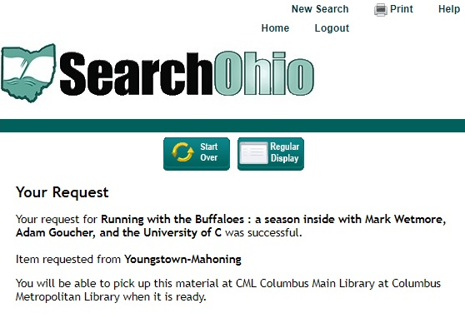
- If the request is successful, you will see a confirmation screen.
Remember to log out the customer when the hold request has been completed.
8

How to Place a Hold in OhioLINK for a Customer
- Follow steps 1-4 from How to Place a Hold in SearchOhio.
- If item is not available in SearchOhio catalog, click on OhioLINK visible on the SearchOhio results screen.

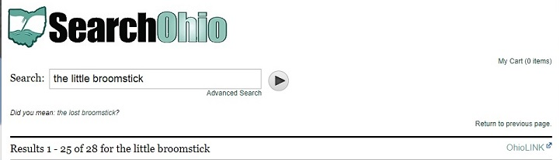
2

- The OhioLINK catalog will open and the search field will auto populate the search terms.

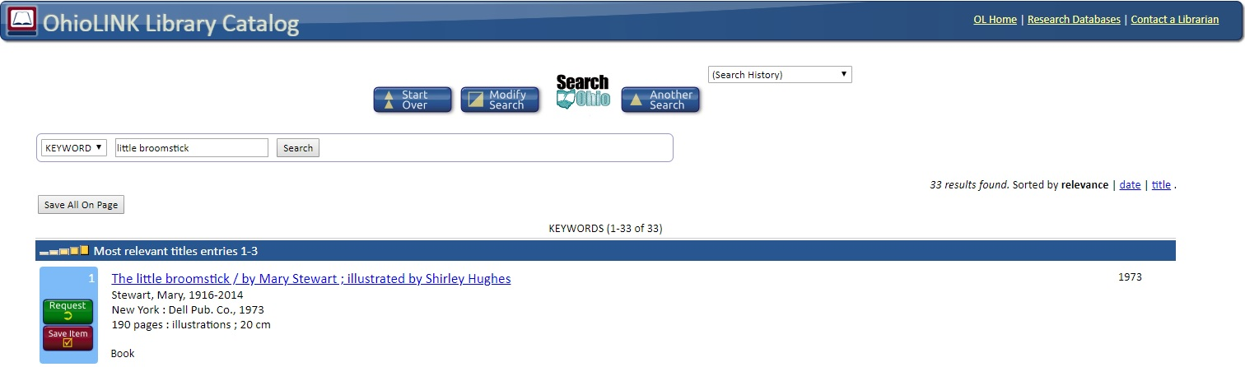
3

- Locate the correct item from the catalog.
Click Request.
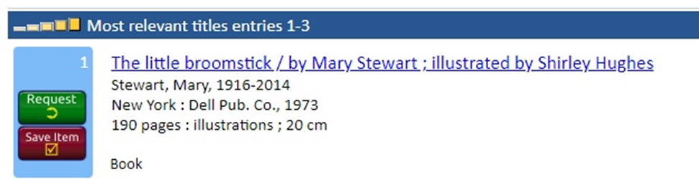
4

- Select Columbus Metropolitan Library.
Click OK
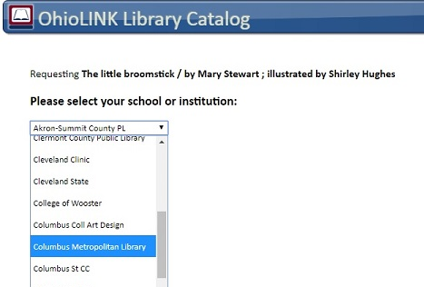
5

- On the Request Verification screen
  - Enter the customer’s last name and library card number.
  - Select the customer’s Pickup Location
  - Click Submit.
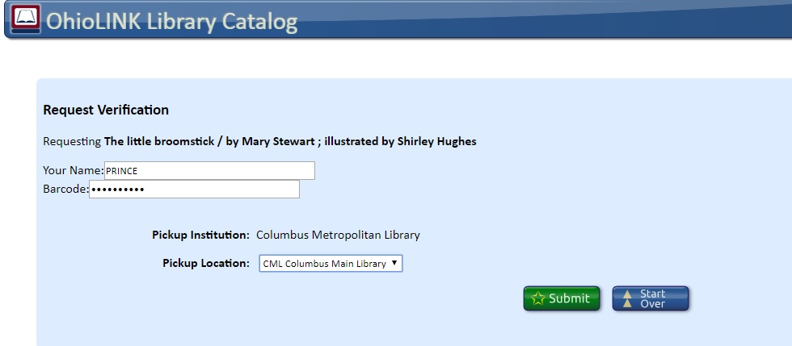
6c
6b
6a

- If the item request is successful, you will see a confirmation screen. Remember to log out the customer when the hold request has been completed.
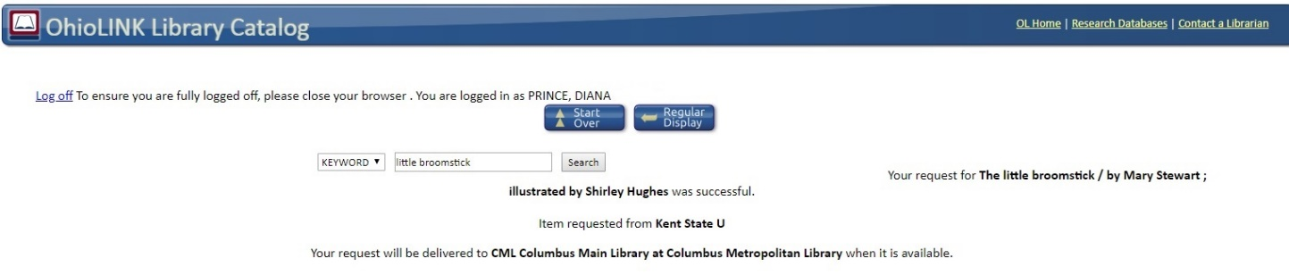
7

