SearchOhio/OhioLINK Outgoing Returns without Labels

- Check in the item from the customer’s account.
- Attach a blank SearchOhio/OhioLINK label to the back of the item.
Determine the owning location’s transportation delivery code by using the spreadsheet of participating SearchOhio/OhioLINK members.
- Using a red sharpie, write the owning location’s transportation delivery code in the middle of the sticker.
- Write owning location’s transportation delivery code in the Destination Location # line.
- Write a large red “R” on the sticker.

*If the item cannot be clearly connected to a customer account then send to ILL.

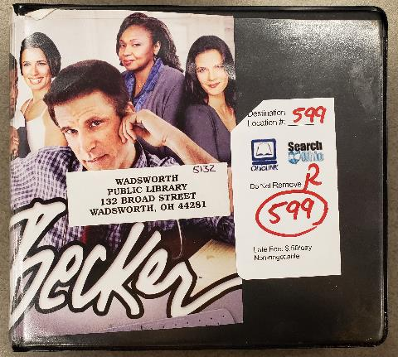
4
5
3
2

