Search Ohio Reserves – Missing Hold

Contact the customer to determine if he or she has the item. If the customer has the item, check the item out to the customer.

- Go to the Patron Status Holds screen
- Find the item under ILL requests, right-click on the item.
- Select Links
- Select Item Record.
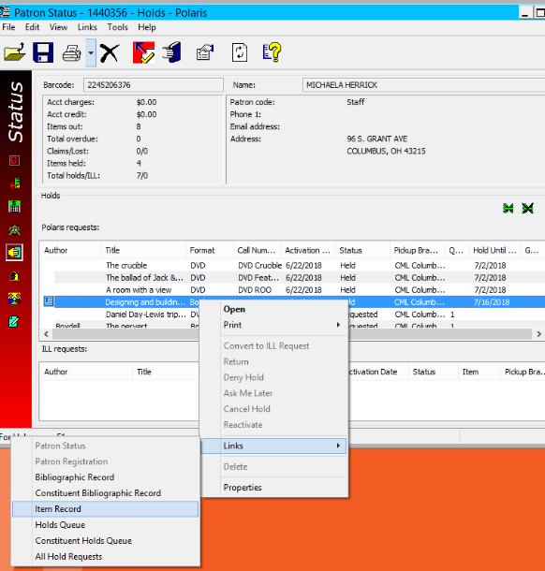
- In the Item Record, select the Item Barcode, right click, and select Copy
4
3
2
1
- Check out the item to the customer.
- Paste the barcode of the item into the item barcode field in the checkout screen.
7
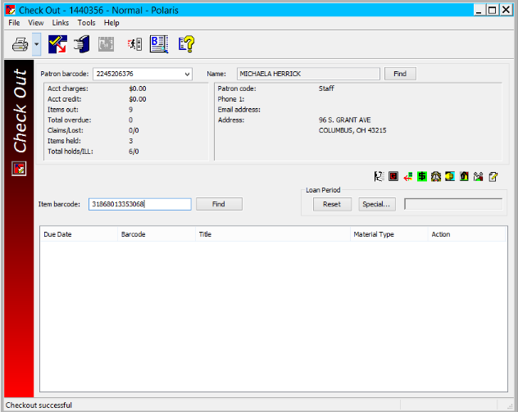
- Add a note to the account
“6/21/18 C-MAN SearchOhio reserve not on shelf “Designing and Building Chairs” contacted customer who has item, checked item out to customer. –Mherrick”

If the customer does not have the item
- Go to the Patron Status Holds screen
- Find the Item under ILL requests, right click on the item.
- Select Links
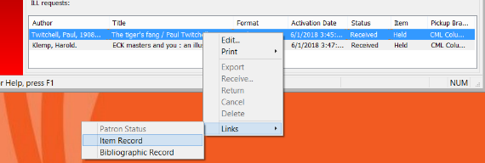
- Select Item Record.
2
4
3

- Click the Check-In icon to check in the item.
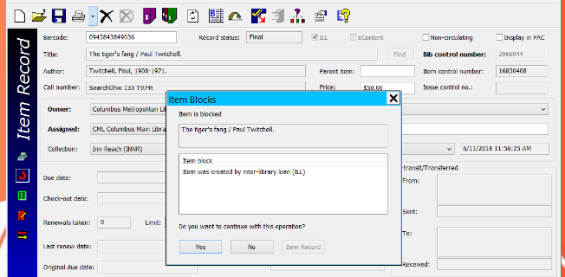
- Click Yes for the item block question Do you want to continue with this operation
6
5

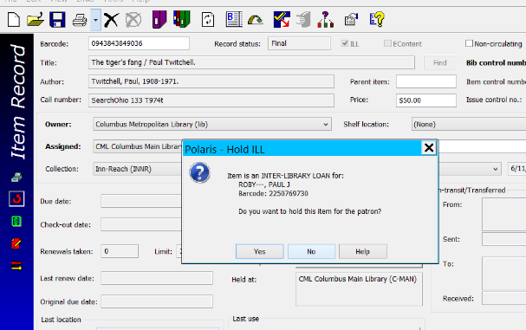
- Click No, when asked to hold the item
7

- Do not contact the owning location.
The item will now display as a Returned-ILL.
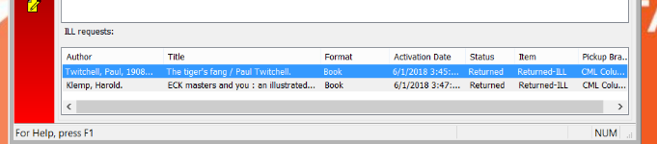
8

- Add a note to the account
6/21/18 C-MAN SearchOhio reserve not on shelf “Tiger’s Fang” checked item in. –Mherrick

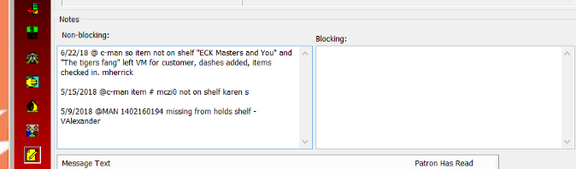
- Follow the “Missing Holds” Service Expectation.
Upon the third instance or single instance of several missing holds, add three dashes to the customer’s last name in the ILS so holds can be held behind the desk.
9

See Also:
Missing Holds Service Expectation
Customer Notes Service Expectation

