Search Ohio – Claims Returned

Before Processing Search Ohio Claims Return

- Use the Claims Returned Service Expectation to evaluate the customer’s claim to determine the likelihood the items were returned.
- Customers are allowed three claims returned items in a three-year period.
- Use good judgment in resolving these issues and refer to notes on the customer’s account for claims history and context.
- Encourage the customer to search for the item(s). When possible, renew the item(s) and let the customer know of upcoming due dates to avoid fees. *Do not call the owning location to perform a shelf check
Processing Search Ohio Claims Returned

If the item was likely returned or never checked out, check the item in.

- On the Patron Status screen, click the Holds screen icon. Find the item under ILL requests.
- Right click on the item
- Select Links
- Click on item record.

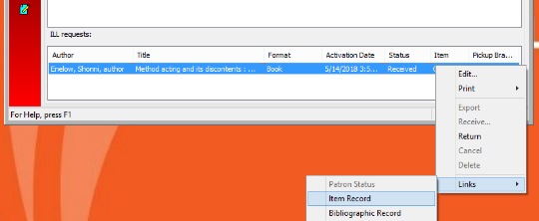
3
4
1 Patron status screen, click Hold icon. Find item

- On the item screen, use the Check-in icon to check-in the item.
There is no need to contact the owning branch. The circulation status will now show “Returned-ILL.”
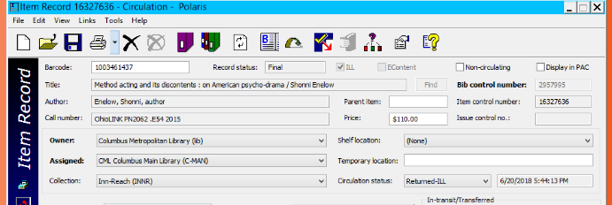
5
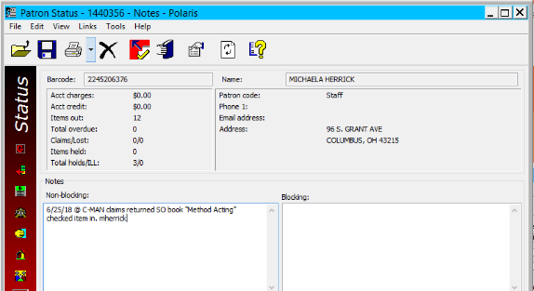
- Add a note the customer’s account.
For example, “6/25/18 @C-MAN customer claims returned SO items “Method Acting.” Checked item in. –Mherrick”
6

If the customer cannot find the items and it is unlikely the items were returned.
The items will be charged to the customer’s account by checking the item out and making the items lost.

Check Out the Item:
- Go to the Patron Status screen
- Find the ILL request
- Right click the ILL request
- Select Links
- Select Item Record
- In the Item Record, Select the Item Barcode, right click, and select copy.
- Select Checkout
- In the item barcode field, right click and select paste, and hit enter
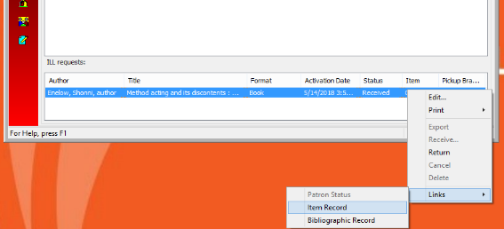
- The item is now checked-out to the customer.
You will follow the next set of instructions to make the item lost
5

2

4

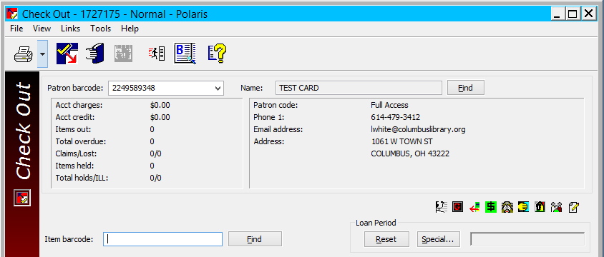
8

7

Make the Item Lost
- Display Items Out view
- Select the ILL request that is now checked out
- Select Declare Lost icon in action box
- Under Replacement, change action box to “Charge”
- Waive the Processing Fee (if it exists).
- Click OK.
- The charge is reflected in the Account view with a note Declared Lost.
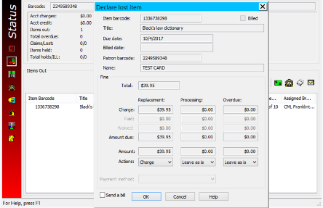
1

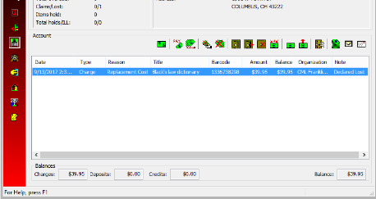
7
6

5

4

3

2

See Also:
Claims Returned Service Expectation
SearchOhio and OhioLINK Service Expectation
Customer Notes Service Expectation

