Charging for a Damaged SearchOhio or OhioLINK Item

- Open Item Records tool.
- Scan barcode of item.
- Double click to open item record.
1

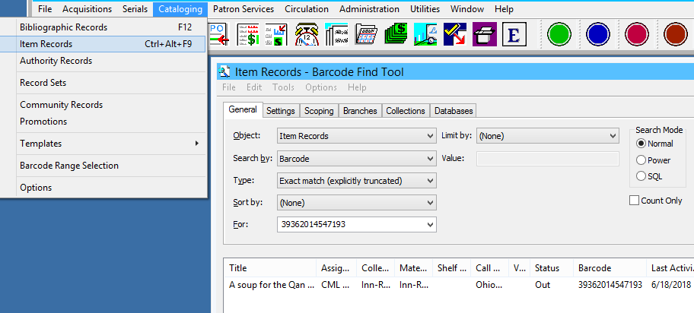

2
3

- From the item screen, copy the item barcode.
- Double click the Current borrower to bring up patron status screen.
- Click the Check-in icon on the item screen.
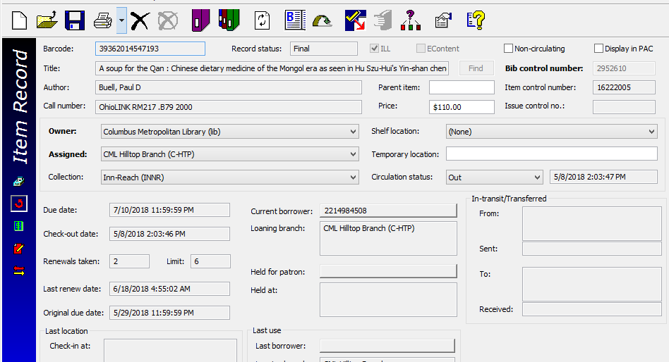
4
6

5

- From the patron status screen click the Account icon.
- Click the Charge icon.
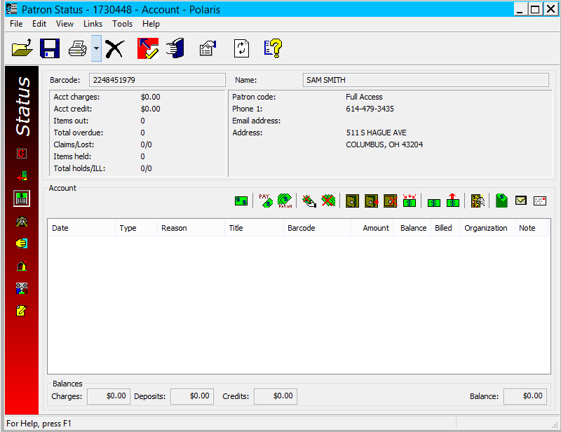

8
7

- Enter the cost:
SearchOhio: $50
OhioLINK: $110
- Reason: SearchOhio/OhioLink Replacement Fee - Manually Applied
- Fill in Notes: Title, barcode, Lost/Damaged (i.e., Soup For the Qan 39362014547193 Damaged)
Leave Associated item barcode blank
- Click OK
9
10
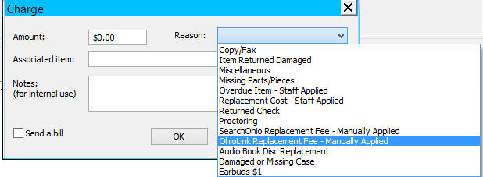
12
11

- The charge for the damaged item will show in the customer’s account.
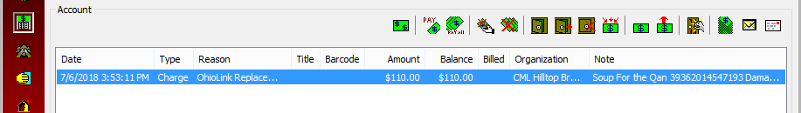
13

- Add a non-blocking note indicating how the customer was notified (i.e., 7/6/18 @C-HTP SearchOhio item returned damaged 39362014547193. Letter sent -Lstith).
Refer to the Patron Blocks and Notes workflow for more information on adding non-blocking notes.
14
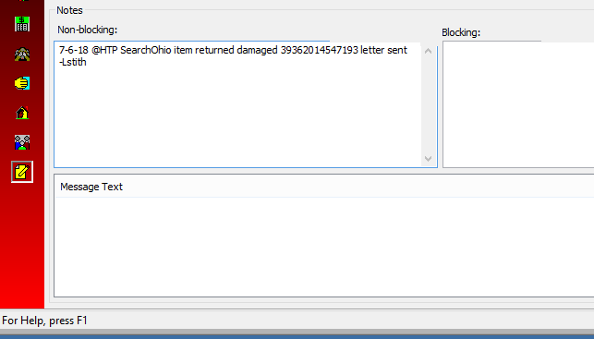

- Print out a copy of the item record and give to your circulation manager so that the owning library can be contacted.
- Circulation managers: email a copy of the item record to the circ lead at the owning library
SearchOhio: http://searchohio.westervillelibrary.org/index.php?title=Library_Members
OhioLINK: http://ostaff.ohiolink.edu/c.php?g=777595&p=5861244
- Circulation managers can also consult the links above to see if a loaning library accepts a replacement copy in place of payment. If the website does not explicitly say that they do, assume the answer is no.

- Replacement copies: put a filled-out SearchOhio sticker on the back and send to owning library with a copy of the item record and a detailed note.

