Changing Pickup Location for SearchOhio Items

Like typical customer reserves, a SearchOhio request may be sent to a different location for pickup after the initial request has been placed. Use the customer’s Requests workform to make this change.

If the item is on Shipped or Active status

- Go to the Requests workform
- Locate the ILL Requests box
- Locate the title the customer is requesting to change and double click
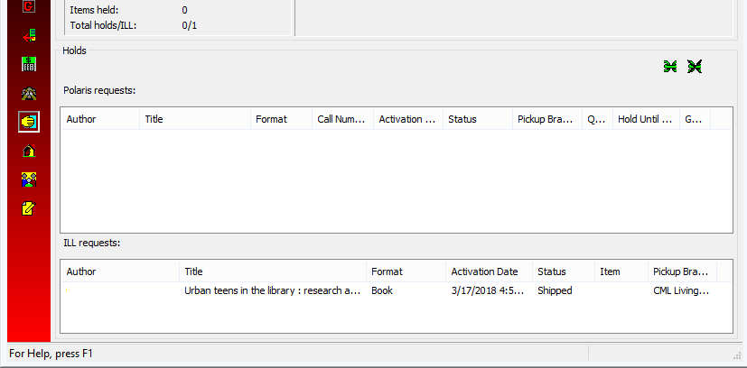
1
3
2

- The ILL request box for the item will open
- From the Delivery box, use the drop down menu to change Pickup branch to the desired location
- Click OK
- Place the item in an OPS-H bin for transfer to new pickup location.

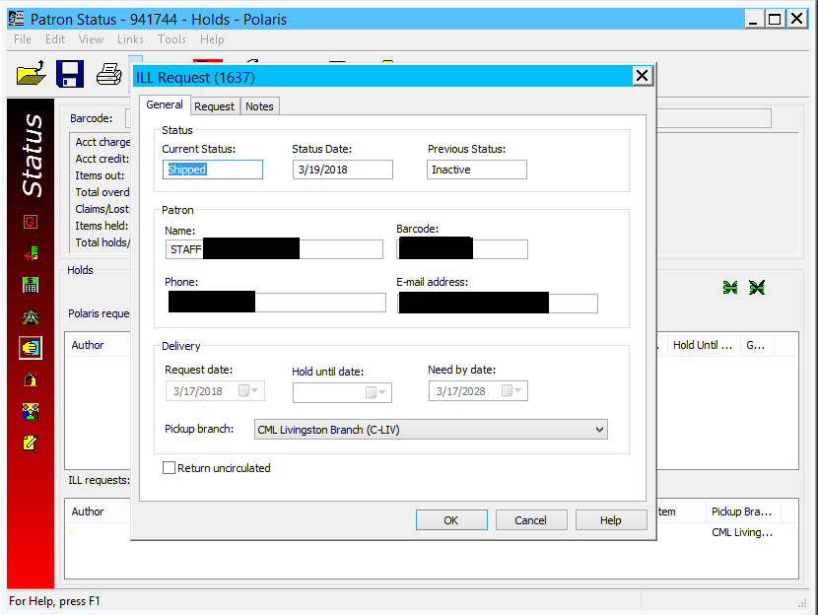
6
5
4

- The SearchOhio request will still arrive at the location initially selected if the item has already been Shipped. CSS and above are to use the Receiving Items workflow to receive the item.

- A slip with the customer name & new pickup location will print once received.

NOTE: If a customer decides they want to cancel their requested SearchOhio item, check the Return uncirculated box from the ILL Request box for the item. This action can only be used if the item status is Active or Shipped.

If the item is on Held status
New location:

- Follow steps 1-6 above.
- The change is not reflected on any view (holds, pull list, item record, etc.) so you must call the other location to send it to your location.
Old location:
- Since the item is already on Held status, a new hold slip cannot be printed.
- Cross out your location and write in the new location at the top of the slip.

- Place the item in an OPS-H bin to be sent to the new location.

